The UK has just [held a Westminster election](https://en.wikipedia.org/wiki/List_of_United_Kingdom_general_elections) to decide the next government. There are some [amazing visualisations](https://twitter.com/VictimOfMaths/status/1203964749802803200) of what’s happened to the whole nation, but I think there’s a story to tell about my local constituency.

Miners were a heavily unionised workforce and I think knowing this helps understand the path of voting patterns.

I’ve been [reading John Harris](https://www.theguardian.com/commentisfree/2019/dec/02/labour-red-wall-brexit-progressive-industrial-england) recently, and I think his approach to listen to differing views helps understand what is going on around us. With this in mind, I’ve annotated a plot of election results for Midlothian since 1955. I made the plot in R (code below), and annotated in [LibreOffice Draw](https://www.libreoffice.org/discover/draw/). The dominance of non-voters since 2001 really highlights how important it is to exercise our democratic right!

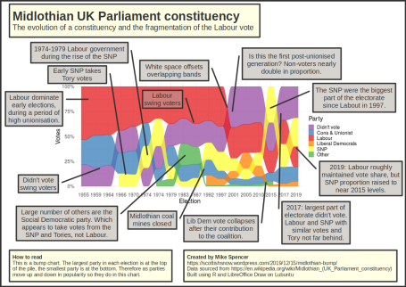

Here’s the R code I used for the bump chart:

library(tidyverse)

library(lubridate)

library(ggalluvial)

votes %>%

mutate(party = fct_expand(party, "Cons & Unionist"),

party = fct_recode(party, `Cons & Unionist` = "Conservative"),

party = fct_recode(party, `Cons & Unionist` = "Unionist"),

party = fct_recode(party, Green = "Scottish Green"),

party = fct_lump(f = party, n = 5),

party = fct_relevel(party, "Didn't vote")) %>%

group_by(id, date, party) %>%

summarise(votes = sum(votes)) %>%

left_join(x %>%

select(id, pop)) %>%

mutate(prop = votes / pop) %>%

ggplot(aes(x = as.character(date), y = prop, alluvium = party)) +

geom_alluvium(aes(fill = party, colour = party),

alpha = .75, decreasing = FALSE) +

scale_x_discrete(labels = str_sub(date, 1, 4)) +

scale_y_continuous(labels = scales::percent) +

scale_colour_manual(values = pal) +

scale_fill_manual(values = pal) +

labs(x = "Election",

y = "Votes",

fill = "Party",

colour = "Party") +

theme_minimal() +

theme(text = element_text(size = 20))